**Planning a career in Computer Science**

***Lead in***

1. What are the motivations you had to follow your domain of study?

2. In your opinion, what are the reasons that prevent a person from following CS?

3. What experience and areas of expertise or interest within the information technology sector and research (both in the public and private industries) do you have?

4. How do you see the role of the degree credentials in shaping (your) future employment prospects?

5. Check the latest data on the state of computer science enrolment (BA programs) in Europe.

<https://www.informatics-europe.org/data/higher-education/statistics/bachelor_all_semesters_ratio.html>

View the data and suggest useful knowledge (data patterns/comparisons) for both yourself and your peers.

***Getting started in research***

***1a. Many students pursue their education in other countries. The table below summarises tertiary (higher education) for science in the US. Make a similar table for your country and then answer the following questions.***

1. Is tertiary education in the US similar to science higher education in your country?
2. If you decided to study abroad, which qualification would be best for you?

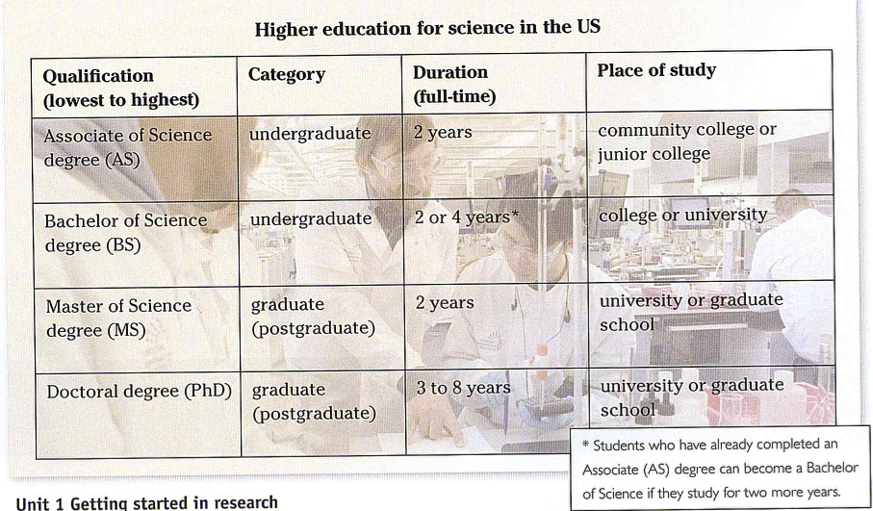

***For further info, also see:***

<https://www.informatics-europe.org/services/informatics-job-platform/5.html>

<https://jobs.theguardian.com/jobs/technology/>

<https://jobs.theguardian.com/jobs/international/it/#browsing>

**1a. Eriko is from Japan and she will soon complete a PhD in CS in London. She is discussing the next stage in her career with her supervisor, Susana. Listen to part of their conversation and write the options that interest her and the options that do not.**

**1b. *What are the advantages and disadvantages of working in academia or industry? Brainstorm and then feed back to the class.***

***2. Think about your career in Computer Science and make notes on:***

* your favourite experience in the courses so far;
* past and present experience that could enhance a career in Computer Science;
* the soft skills vs. the specific technical skills an ideal computer professional (give at least 2 examples for each type of skill);
* your ideal job interview: a code walk-through or a focus on the currency of your skills/employability portfolio;

**Use your notes and discuss them in plenary.**

Asynchronous work

Watch the following video (10:32) <https://www.youtube.com/watch?v=FpMNs7H24X0>

and select one relevant idea that you would use as focus for a podcast programme supported by the Faculty’s Website/your own blog.